At start (2-3)

* Topic
  + Investigating carbon emissions per capita to understand spatial and temporal emission changes
* Goals, objectives
  + To determine whether environmentally-friendly measures are actually making a difference?
  + Focus on the carbon output of various vehicles and electronics
  + Conclusion A: We are making a difference!
  + Conclusion B: No, the world is doomed!
  + We take B and try to prove ourselves wrong.
* Type of system (analysis, presentation, etc)
  + Narrative
  + Scrollytelling
  + Drill down
* Supported queries, insights, knowledge
  + Countries that have a high per capita emission. why?
  + Emissions over time, group by different categories or whatever
  + Put carbon output of various vehicles, electronics, etc in relative perspective by comparing them visually (vs each other or vs total emissions from the country)
    - <https://www.statista.com/chart/32690/estimated-life-cycle-greenhouse-gas-emissions-of-electronic-devices/>
    - <https://medium.com/@laurariehl/the-carbon-footprint-of-everyday-technology-57d97db6c2e4>
    - <https://www.nature.com/articles/s41598-024-54271-x>
    - <https://unctad.org/publication/digital-economy-report-2024>
  + Do current technologies such as EVs reduce carbon emissions in **any meaningful way**?
  + Are countries that are pushing greener policies making a big impact on their emissions due to such policies?
  + highlighting a few countries and compare?
  + 8-10 graphs/visuals total

### **Chapter 1: Overview of Global Carbon Emissions Per Capita**

* **Visualization 1**: World map highlighting countries with the highest per capita carbon emissions.
* **Insights**: Describe any trends or patterns, like regional emissions or economic factors, using Tableau’s map visualization.
* **Supported Queries**: Which countries have the highest per capita emissions? Why might these countries have high emissions?

Currently using: [co2_emissions_kt_by_country](https://www.kaggle.com/datasets/ulrikthygepedersen/co2-emissions-by-country)

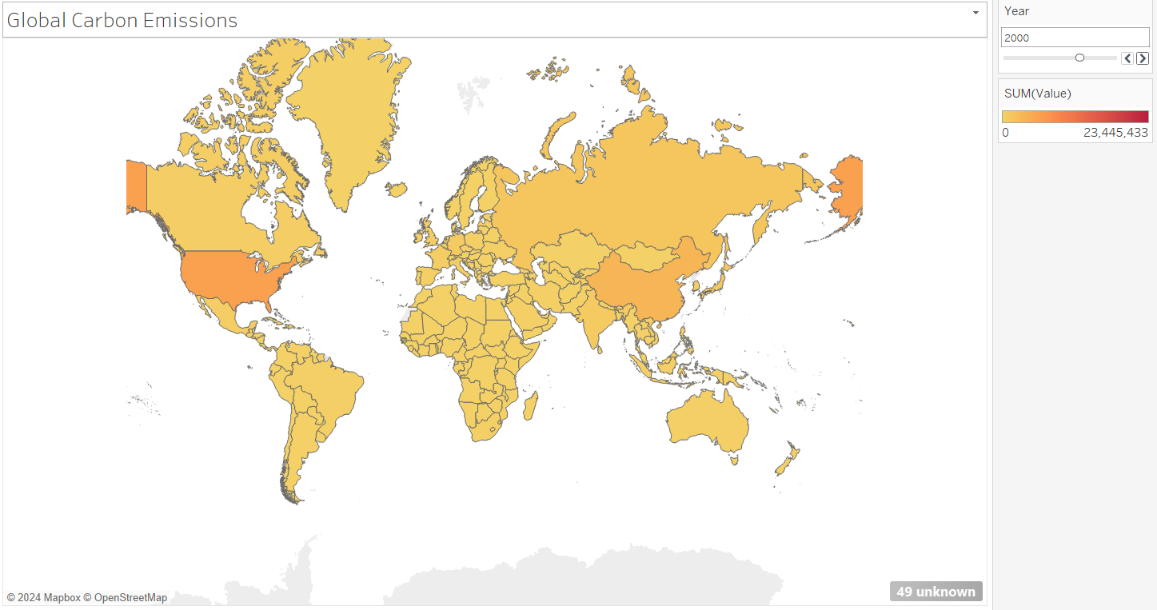

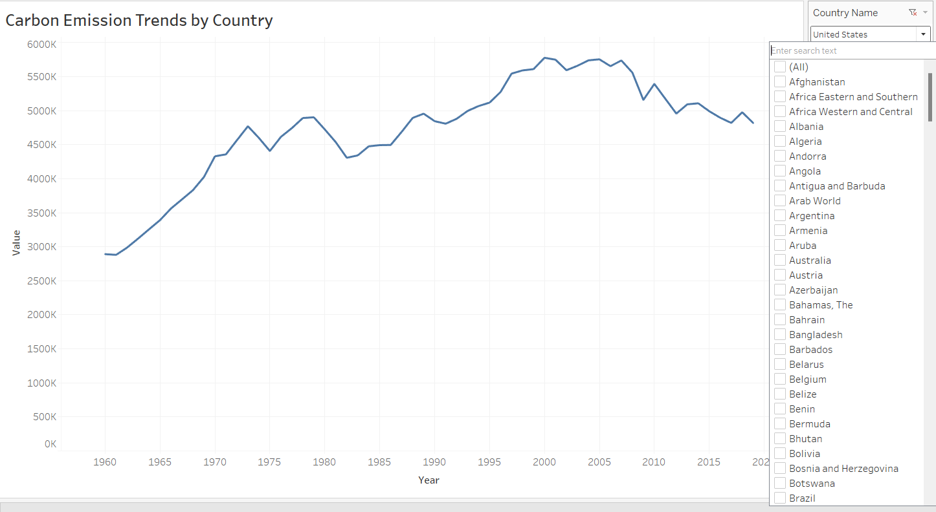

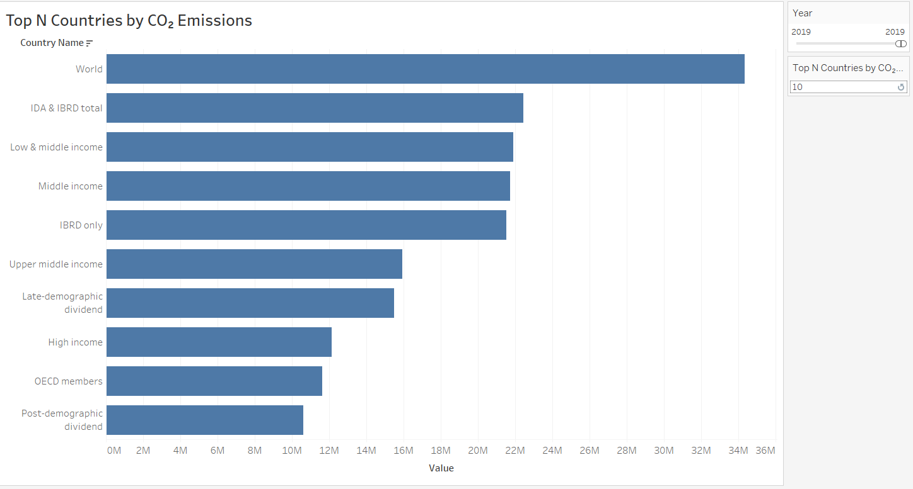

Plan to consider:

☆ [Carbon Emissions - Global Carbon Atlas](https://globalcarbonatlas.org/emissions/carbon-emissions/)

[Our World in Data](https://ourworldindata.org/)

### **Chapter 2: Temporal Analysis of Emissions**

* **Visualization 2**: Line graph showing carbon emissions per capita over time for a select group of countries.
* **Visualization 3**: Interactive bar chart or area chart breaking down emissions by category (e.g., transport, energy, electronics).
* **Insights**: Look at temporal changes to see if countries implementing greener policies show reduced emissions.
* **Supported Queries**: How have emissions changed over time? Are policy shifts or innovations reflected in these changes？

### **Chapter 3: Sector Comparison of Carbon Output**

* **Visualization 4**: Comparative bar chart showing carbon output of various vehicles (e.g., gasoline vs. electric).
* **Visualization 5**: Bar or pie chart for carbon output of electronics (using data from Statista and Medium articles).
* **Insights**: Help users visualize the relative impact of different sectors and products.
* **Supported Queries**: How does carbon output vary across different types of vehicles and electronics? What are the high-impact areas?

### **Chapter 4: Technological Impact on Emissions (e.g., Electric Vehicles and Electronics)**

* **Visualization 6**: Side-by-side comparison chart showing lifecycle emissions of EVs vs. traditional vehicles.
* **Visualization 7**: Bubble chart showing carbon output per capita for countries adopting new technologies, highlighting those with meaningful reductions.
* **Insights**: Examine if new technologies are making significant differences in reducing emissions.
* **Supported Queries**: Are EVs and greener electronics reducing emissions? How effective are these technologies?

### **Chapter 5: Country-Level Comparisons on Green Policies**

* **Visualization 8**: Comparative line graph of a few countries (e.g., USA, China, Germany) showing emissions before and after implementing green policies.
* **Insights**: Use real-life data to analyze the impact of green policies on emissions, contrasting countries with high vs. low environmental policy impact.
* **Supported Queries**: Which countries have succeeded with green policies? Are the results substantial?

### **Conclusion: Can We Prove Ourselves Wrong?**

* **Summary**: Recap findings to answer the question: “Are environmentally-friendly measures making a difference?”
* **Reflection**: If the data doesn’t support “Conclusion B,” explain where emissions are being effectively reduced and provide an optimistic outlook.
* **Next Steps**: Discuss possible future areas of research or data collection to continue evaluating the impact of green measures on global emissions.
* different kinds of charts
* more complex designs

Past Semesters:

<https://faculty.cc.gatech.edu/~stasko/6730/21s/Projects/>

<https://faculty.cc.gatech.edu/~stasko/6730/21f/Projects/>

<https://faculty.cc.gatech.edu/~stasko/6730/23f/Projects/>

<https://delen0828.github.io/DVP-Project/>

emissions goals by 2030 for countries vs their actual

Datasets:

* Alex
  + focused more on various tech and their carbon emissions
  + individual carbon footprint
  + <https://www.carbonfootprint.com/energyconsumption.html> - carbon footprint of appliances
  + <https://www.statista.com/chart/32690/estimated-life-cycle-greenhouse-gas-emissions-of-electronic-devices/> - carbon footprint of personal devices
  + <https://www.iea.org/data-and-statistics/data-product/net-zero-by-2050-scenario> - net zero

Ranon

We can follow something similar along this thing:

<https://www.cbo.gov/publication/58861#_idTextAnchor050>

Data source on vehicles:

<https://www.epa.gov/greenvehicles/fast-facts-transportation-greenhouse-gas-emissions>

This website talks about carbon footprint per person:

<https://ourworldindata.org/travel-carbon-footprint>

IEA:<https://www.iea.org/energy-system/transport/aviation>

Different sorts of transportation modes

Conversion calculator:

This is the ending for our project?

<https://www.epa.gov/energy/greenhouse-gas-equivalencies-calculator#results>

More data:

https://www.eia.gov/environment/emissions/state/